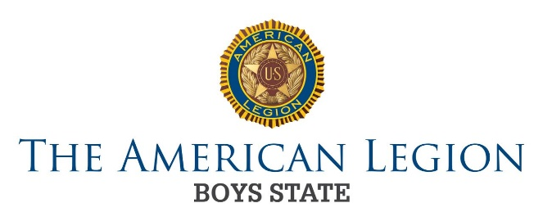
FOR IMMEDIATE RELEASE

Media Contact: ____________
Phone: ____________
Email: ____________

High school students participate in The American Legion Boys State educational program

Democracy in action provides engaged students with experience
and education about the structure and operation of state government

DATE (CITY, STATE) – On Date, The American Legion Boys State program, held in Town, hosted more than ### students from across State. The program activity provides young men with the opportunity to learn firsthand about what it means to be engaged in their community and participate in a democratic society. The American Legion has been administering the non-partisan program nationally since 1935 and this is the XX year that State residents have gathered for this important civic activity.

Set at Location, student delegates design a model state, complete with governmental bodies and elected public officials. The program mirrors the structure and operation of state government while providing training in practical citizenship, leadership, character and public service.

“As part of the planning committee, this was a personally rewarding experience and it was impressive to see the students’ commitment to getting the most out of the opportunity to learn about the democratic process firsthand,” said Name, director of The American Legion Boys State program. “A number of delegates said it was a life-changing week of learning. I am confident that the future of our country is in good hands.”

The program aims to inspire students to follow in the footsteps of former delegates. The list of notable alums includes President Bill Clinton, athlete Michael Jordan, rock star Jon Bon Jovi, news personality Tom Brokaw, and former U.S. Peace Corps director Gaddi Vasquez, to name a few.

# state-level college scholarships were awarded and two delegates were elected to attend The American Legion Boys Nation program in Washington, D.C. in Month.

SAMPLE QUOTE: “The American Legion Boys State program has truly opened my eyes to how our government works,” said Name, a participant from Town. “I am honored to have been selected to participate in Boys Nation in Washington, D.C. and I plan to represent State well.”

The two young men selected to represent The State American Legion Boys State program are Name from City and Name from City.

About The American Legion
The American Legion is the largest wartime veterans service organization with nearly 2 million members in 12,875 posts in communities across America. Chartered by Congress in 1919, The American Legion is committed to mentoring youth and sponsoring wholesome programs in our communities, advocating patriotism and honor, promoting a strong national security, and continued devotion to our fellow servicemembers and veterans.

###

