Manual Of Ceremonies: | How To Conduct A Post Meeting
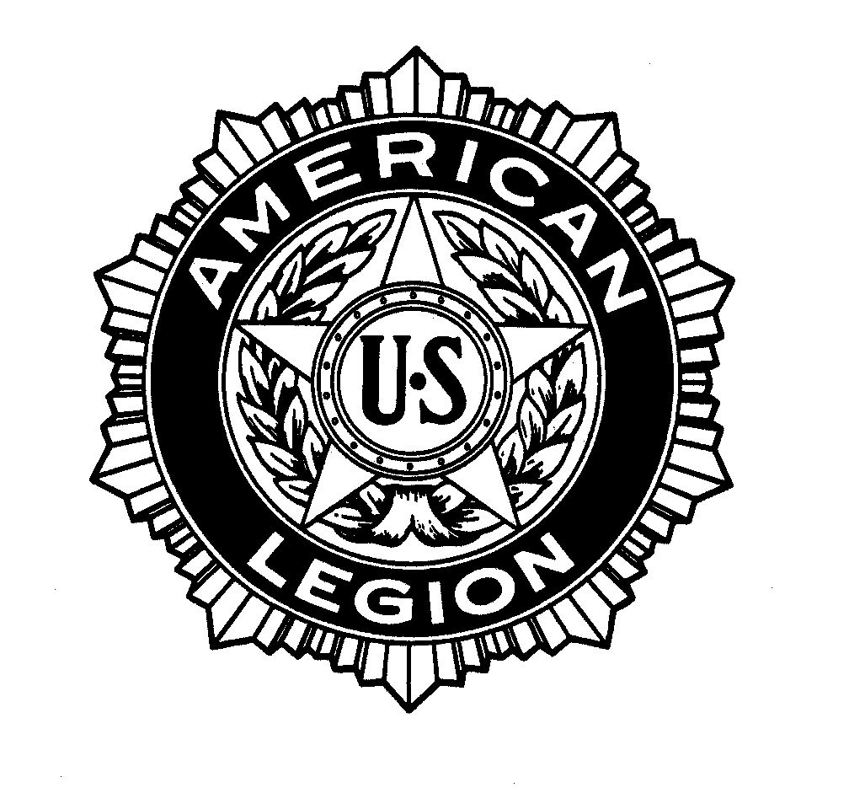

The American Legion

Department of Michigan

POST

COMMANDER

ADJUTANT

Ceremony For Regular Meetings
(Bold-face type below indicates the Commander speaking)

- Opening one rap of gavel
(seat those present and have the Sergeant-at-Arms close doors of meeting hall)

- Three raps of gavel (all those present will stand)

- “The Color Bearer(s) (or Sergeant-at-Arms) will advance the Colors.”
“HAND SALUTE! TWO!”

- “All in attendance will stand and remain uncovered with their cap removed and placed over the heart from the opening prayer, through the POW/MIA ceremony and concluding with the Pledge of Allegiance.”
(Female Legionnaires are afforded the opportunity to leave their cap on during the Pledge of Allegiance, POW/MIA ceremony, while standing in silent reverence in memory of departed comrades, and prayer. See Officers Guide, p. 42, #8)

- “The Chaplain will offer prayer.”

POW/MIA Empty Chair Ceremony
- “A POW/MIA Empty Chair is placed at all official meetings of The American Legion, as a physical symbol of the thousands of American POW/MIAs still unaccounted for from all wars and conflicts involving the United States of America. This is a reminder for all of us to spare no effort to secure the release of any American prisoners from captivity, the repatriation of the remains of those who died bravely in defense of liberty and a full accounting of those missing. Let us rededicate ourselves for this vital endeavor”

- “We will now recite the Pledge of Allegiance. I pledge allegiance, to the Flag, of the United States of America, and to the Republic for which it stands, one Nation under God, indivisible, with liberty and justice for all.”

Recover
- “Recite in unison the preamble to our Constitution.”
“For God and Country, we associate ourselves together for the following purposes: To uphold and defend the Constitution of the United States of America; To maintain law and order; To foster and perpetuate a one hundred percent Americanism; To preserve the memories and incidents of our associations in all Wars; To inculcate a sense of individual obligation to the community, state and nation; To combat the autocracy of both the classes and the masses; To make right the master of might; To promote peace and good will on earth; To safeguard and transmit to posterity the principles of Justice, Freedom and Democracy; To consecrate and sanctify our comradeship by our devotion to mutual helpfulness.”

- One rap of gavel to seat the members
- “I now declare _________________________________ Post Number ________
regularly convened.”

- Suggested Order Of Business:
- Roll Call of Officers to determine if quorum is present
- Reading of minutes of previous meeting (vote on adoption)
- Reading of minutes of previous Executive Committee Meeting
(vote on adoption)
- Introduction of guests and prospective new members (see back cover)
- Committee Reports:
Finance Officer
Membership Chairman (balloting on new members)
2nd Vice Post Activities
Americanism Committee
Athletic Committee
Canteen (house chairman; if appropriate)
- Sick call, relief and employment
- Post Service Officer’s report
- Unfinished business
- Initiation of candidates (new members)
- New business (and correspondence)
- Memorial to departed post member (if appropriate)
- Business for the Good of The American Legion
(membership shall be permitted to make any suggestions of any kind, character or description, save of religion or partisan politics) No motions

Closing Ceremony
- “Is there any further business to come before the meeting? If not, the Chaplain will lead us in the closing prayer.”

- Three raps of gavel. (membership shall rise and uncover, standing in silence with right hand over heart)

Recover Commander’s Charge
- “Till we meet again let us remember that our obligation to our Country can be fulfilled only by the faithful performance of all duties of citizenship. Let service to the community, state and nation be ever a main objective of The American Legion and its members. Let us be ever watchful of the honor of our Country, our organization and ourselves, that nothing shall swerve us from the path of Justice, Freedom and Democracy.”

- “The Color Bearer(s) will retire the Flag of Our Country.”
“HAND SALUTE! TWO!”

- “I now declare this meeting of ___________________ Post Number ________ The American Legion, Department of Michigan adjourned.”

- One rap of gavel
Introduction Of Guests // Reverse Order For Speakers
Special Guest(s)/Guest Speaker(s)
Department Officers (Legion, Auxiliary, SAL)
National Officers (Legion, Auxiliary, SAL), District Officers
County Officers, Legionnaires

Plan of Post Meeting Room
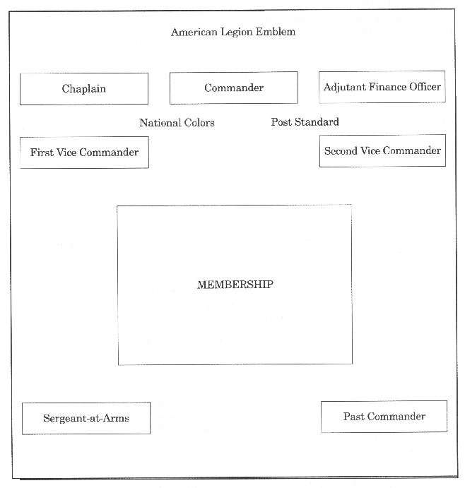
This arrangement of a post meeting room is especially functional for the conduct of regular post meetings. This plan permits the post a great amount of flexibility in arrangement to meet the post’s particular needs and/or adapt to any physical limitations.

Officer’s Guide and Manual of Ceremonies: Section 2 (Revised May, 2015)

